

**REPORT**

**Date:-31.01.2023**

**Name of activity:-** Report on frontend taxi fare website.

**Date of activity:-**31.01.23

**Names:-**

* + Afzal Ahmed
  + Drishti Jain
  + Anjali Prajapati
  + Jayesh patidar
  + Rohit Gupta
  + Eshita Nagariya

**Description:-**

Our team recently completed a taxi fare website for a local cab company. The website was designed to provide customers with an easy to use, convenient way to book a cab and view the estimated fare for their journey. The website was built with a modern, responsive design that is optimized for all devices.

We began by gathering requirements from the client and designing the user interface. We then developed the frontend using HTML, CSS.

Finally, we launched the website and provided training to the client's staff so they could maintain the website and make changes if needed.

Overall, the website was a success and is now helping customers to book cabs and view fares quickly.

**Outcomes:-**

Outcomes about experience of task done by team on frontend taxi fare website🡪

1.The team was able to complete the task in record time, demonstrating a high level of efficiency and collaboration.

2.The team was able to identify and resolve a number of issues with the website, resulting in a smoother user experience.

3.The team was able to implement a number of user-friendly features that improved the website’s overall usability.

4.The team was able to create a visually appealing design that was easy to use and navigate.

**Snapshort:-**

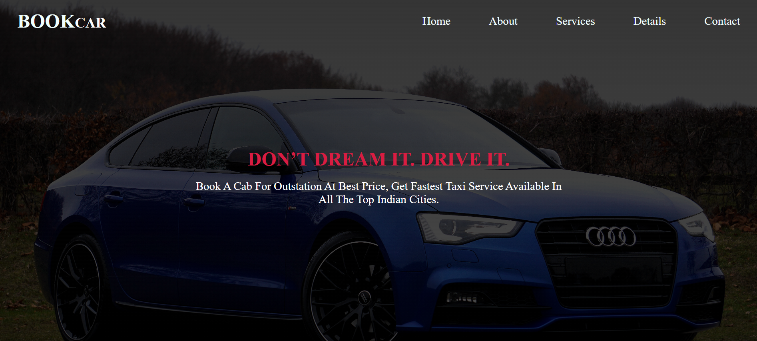

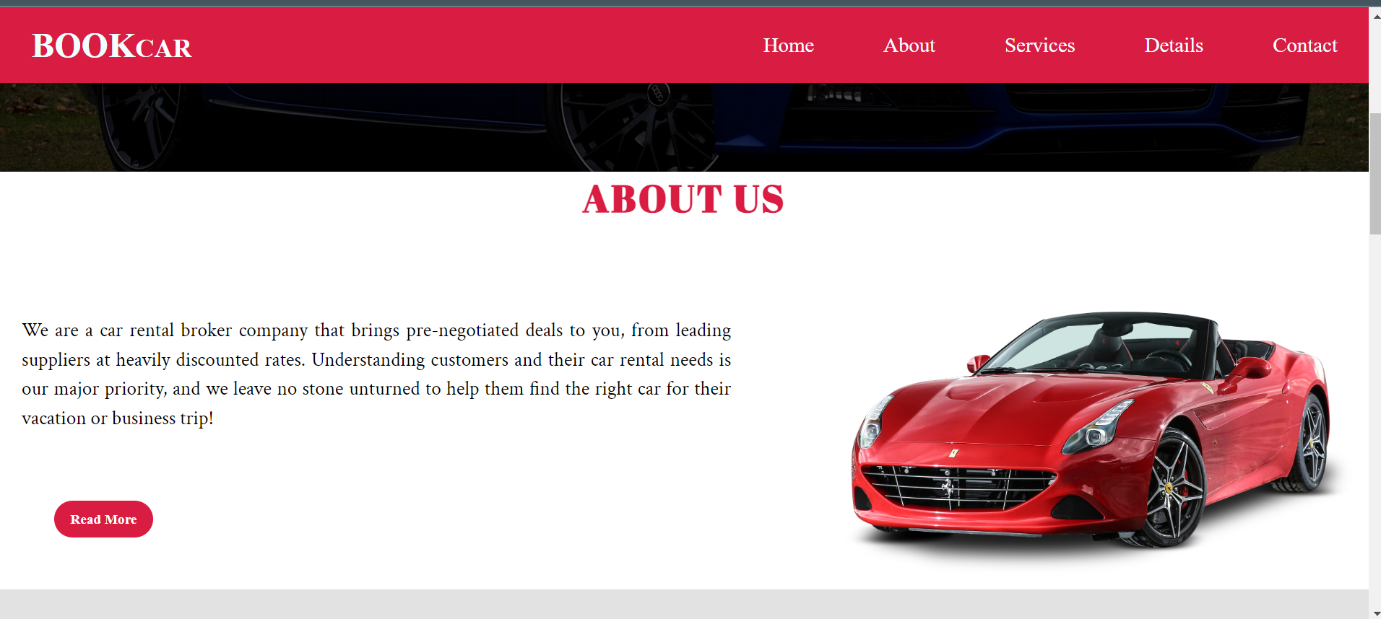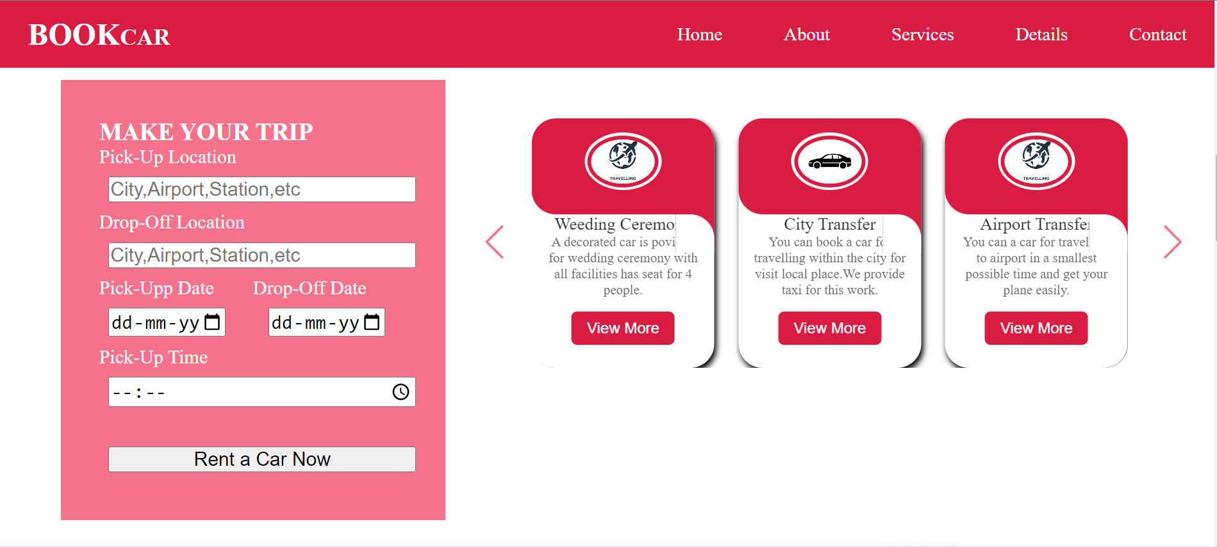

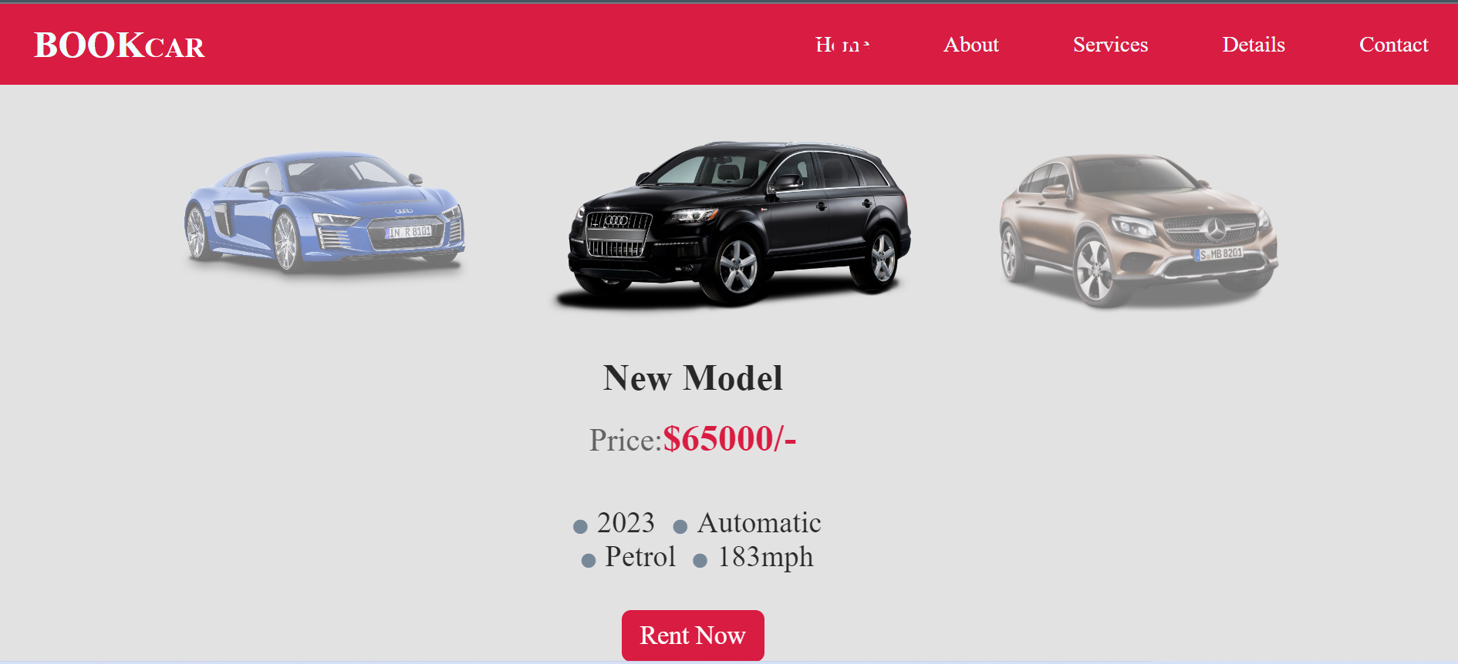

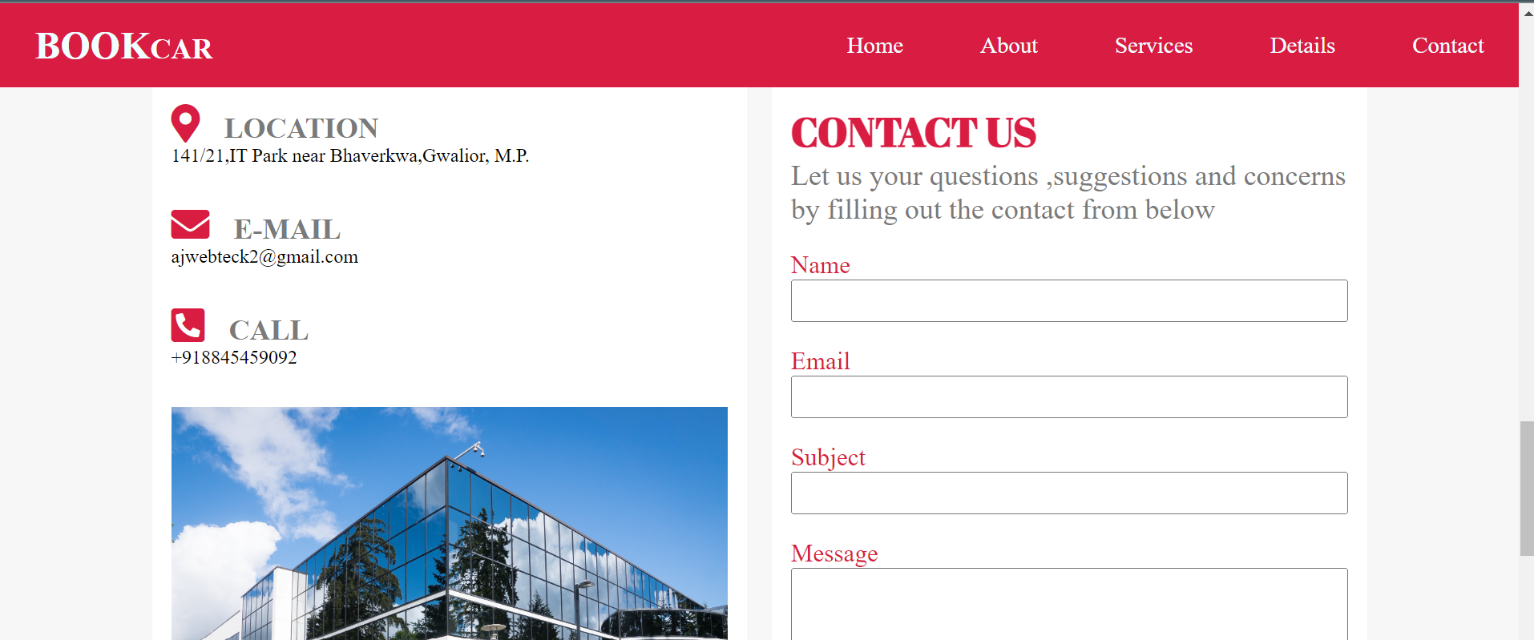

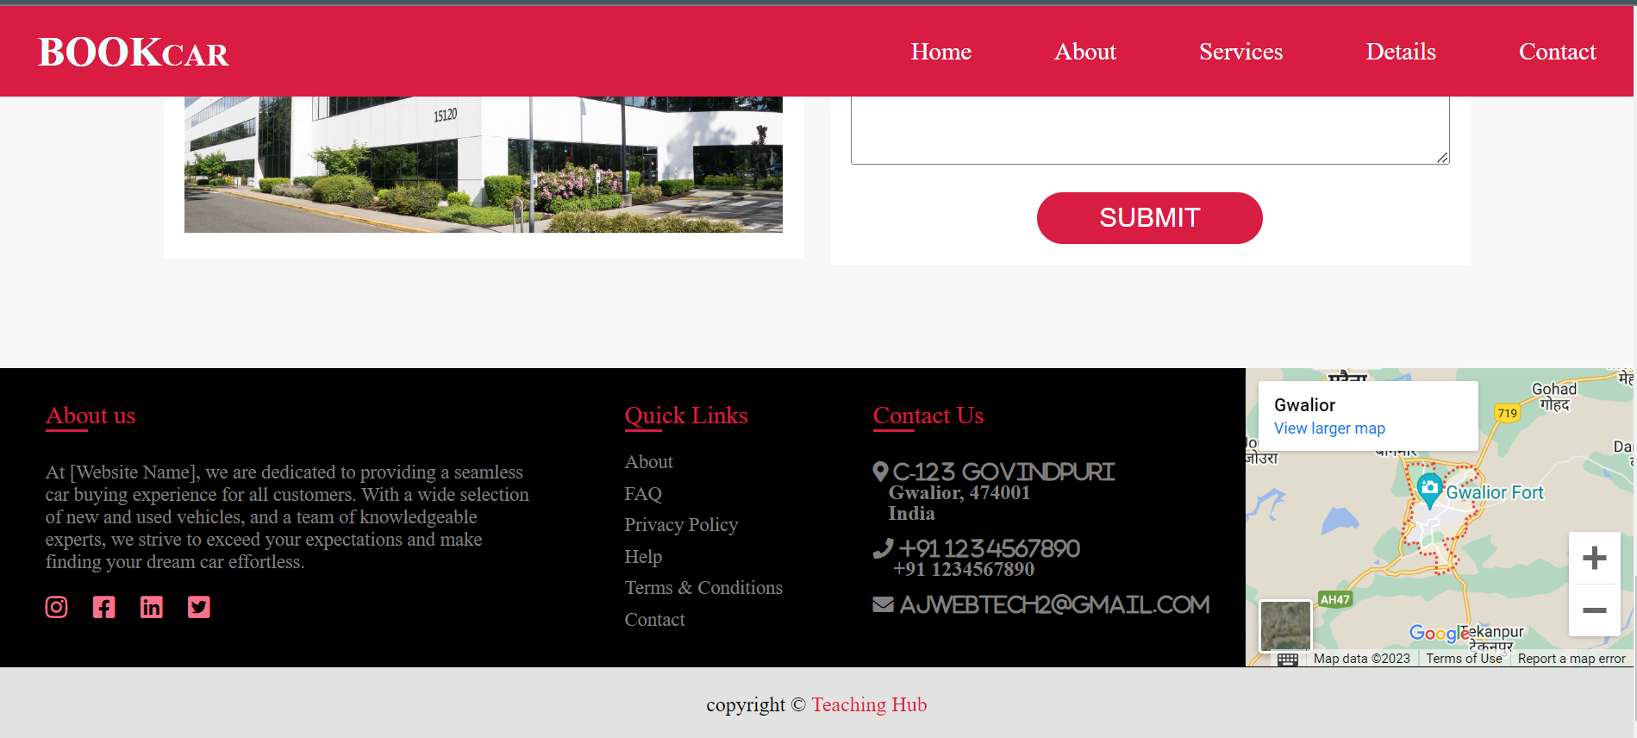

**Mobile Display:**

 

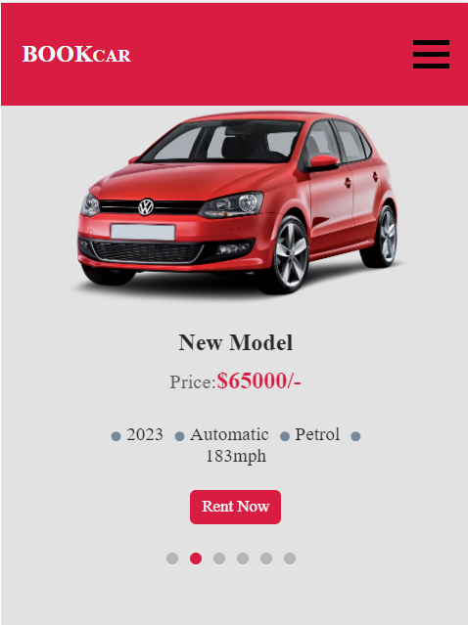 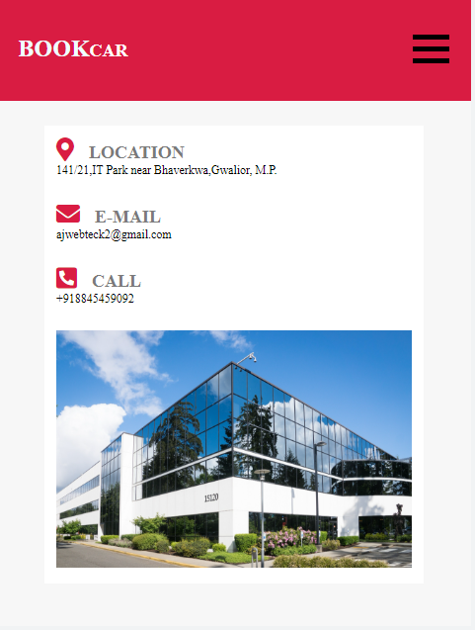

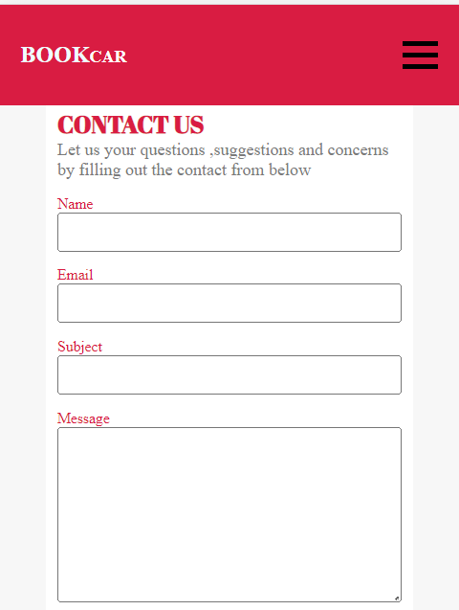 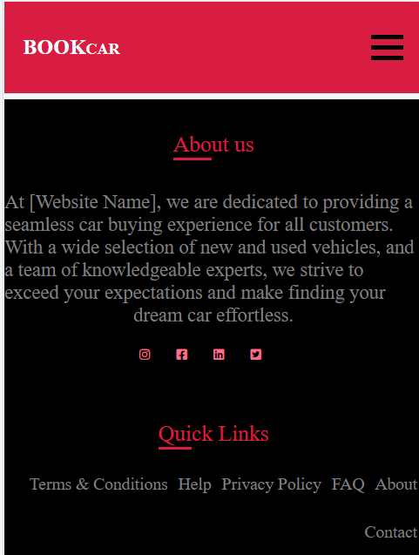

**Rohani Dangi**

**HR Manager,**

**Teaching hub,**

**Gwalior**